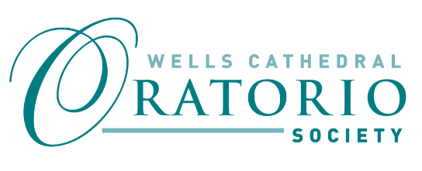
WELLS CATHEDRAL ORATORIO SOCIETY (WCOS) - FRIEND’S SUBSCRIPTION
The WCOS Friend’s subscription is currently £30 per calendar year for an individual membership or £45 for a joint membership. Our Treasurer will invoice you upon receipt of this completed form and the charge will be pro-rata if you join mid-year. You will then be invoiced in December each year ahead of the start of the new calendar year.
This is an application for Individual/Joint Membership* *please delete as appropriate
Your Details:
Title: ……… First Name: .......................................... Last Name: ..................................
Title*:……… First Name*:………………………………………. Last Name*:……………………………….
Address: …………………………………………………………………………………………………………...................................
Postcode: ....................................... Telephone: ....................................................................
Email for correspondence from WCOS: …………...............................................................
DONOR DECLARATION
Please complete if you are personally eligible to Gift Aid
I wish to Gift Aid the above Friend’s subscription and any other donations I make to the Wells Oratorio Society. I am a UK taxpayer and understand that if I pay less Income Tax and/or Capital Gains tax in the current tax year than the amount of Gift Aid claimed on all my donations in that tax year it is my responsibility to pay any difference.
Signature 1: …………………………………………….............. Date: ………………..
Signature 2 (joint membership): ………………………………………… Date………………….
Please notify the society if: • You change your name or address • You no longer pay sufficient tax on your income and capital gains • You wish to cancel this declaration for any other reason.
Please email or post this form to:
Sue Curragh, WCOS Friends Secretary, 40 North Road, Wells, BA5 2TL
E mail: friends@wcos.org.uk

